KET Virtual Physics Labs |  |  |  | KET © 2019
Name |  | _______ Date

Force Table Lab Report

Vector Addition and Resolution

PROCEDURE

A.

5. | Experimental Equilibrant, E: |  |  |  |  | 0.54 |  | g N, | 313 °
6. | Predicted Resultant, R: | 0.55 |  | g N, | 45 |  |  | °
7. | Experimental Resultant, R: |  |  | 0.54 |  | g N, |  | 47 | °
B.
1. | Graphical Resultant, R: 0.54 |  |  | g N, 47 °
Figure 2: Graphical Addition Equilibrant

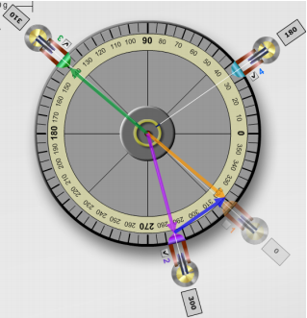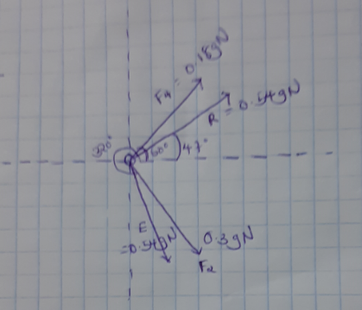

2. Graphical Equilibrant, E:= 0.54 gN 313°

- Draw each of the four vector arrows on Figure 2. Vectors F2 and F4 should be shown added in their tail to head arrangement. The E and R vectors should be shown radiating out from the central pin.

Label each vector with its force value in g N units.

- Take a Screenshot of the force table showing your four force vectors. Make it large enough to include the MT/MR text boxes displaying
the mass values. Disable pulley 1 so as to show the system in equilibrium. Save the
figure locally as “FTable_2.png”, print it out,

and paste it in the space provided.

- Describe what we mean by the terms resultant and equilibrant in relation to the forces acting in this experiment?

Resultant expresses the single force that takes up the effect of many or a number of forces. Equilibrant on the on the other hand is an exact opposite of resultant, therefore resultant and equilibrant have equal magnitudes but with opposite directions.

- From your figures, which two forces, when added would equal zero?

Circle two F2 F4 E R

- Show this graphical addition in the space to the right. You’ll want to offset them a bit since they would otherwise be on top of one another.

- Create the same arrangement somewhere on the screen on your apparatus. Take a Screenshot, save it locally as “FTable_3.png”, print it out, and paste it in the space provided.

- What three vectors, when added would equal zero?

Circle three F2 F4 E R

- Show this graphical addition in the space to the right.

- Create the same arrangement somewhere on the screen on your apparatus. Take a Screenshot, save it locally as “FTable_4.png”, print it out, and paste it in the space provided.

Figure 3: Two Forces Adding to
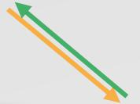

Zero
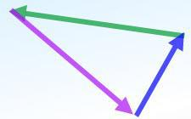

Figure 4: Three Forces Adding

to Zero

12. Vector E should appear in both Figure 3 and Figure 4. Why?

Vectors are characterized by having both magnitude and direction, our forces have both magnitude and direction. Vector E should appear in both cases to express magnitude and directions of our forces.

VPL Lab - Force Table 3 Rev 12/19/18

C. Analytical addition with components

- Add F2x and F4x together.

F2x +F4x = 0.24+0.138=0.368

- How do these two vectors relate to F1x that is, Rx?

Rx = F2x +F4x = 0.24+0.138=0.368

- Repeat with the y-components. What similar statement can you make about the y-components?

Ry = F2y + F4y= 0.24+0.156=0.396

- Finally, how is R related to Rx and Ry?

R² = Rx² + Ry² =$\sqrt{0.368^{2} + 0.396^{2}}$= 0.54

- You’ve found experimentally and graphically how to add the forces F2 and F4 to produce the resultant, R. Now let’s try analytical addition. Using the table provided, find the components of F2 and F4 and add them to find the components of R. Use these components of R to determine the magnitude and direction of R. Note that one of the four components will have a negative sign. The components now displayed on the force table should make it clear why.

- Show all your calculations leading to your value for R below. Remember, a vector has both a magnitude and a direction. A summary of the steps is provided to get you started.

VPL Lab - Force Table 4 Rev 12/19/18

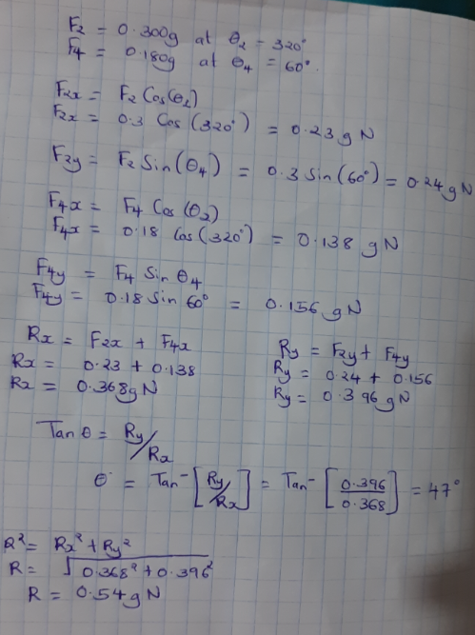

x-Components |  |  | y-Components
F2x | = | 0.23 g N | F2y | = | 0.24g N
F4x | = | 0.138g N | F4y | = | 0.156g N
Rx = |  | 0.368g N | Ry = |  | 0.396g N

R = | 0.54g N, | At 47° | (State your angle between 0 and 360°.)

F2x = F2 cos(θ2) = .300 g N cos(θ2)  F2x = 0.3 Cos 320° = 0.23 gN  F4x = 0.18Cos 320° = 0.138 gN |  |  | F2y = F2 sin(θ4) = .300 g N sin(θ4)  F2y= 0.3 Sin 60° = 0.24 gN  F4y = 0.18 sin 60° = 0.156 gN
Rx = F2x +F4x 0.24+0.138=0.368 |  | Ry = F2y + F4y  = 0.24+0.156=0.396 | R² = Rx² + Ry²  =$\sqrt{0.368^{2} + 0.396^{2}}$= 0.54 | Tan(θ) = Ry/Rx  θ = tan⁻(0.396/0.368) = 47°

VPL Lab - Force Table 5 Rev 12/19/18

- Repeat with the y-components. What similar statement can you make about the y-components

Fy = Fsin(θ)
Ry = F2y + F4y = 0.24+0.156=0.396

KET Virtual Physics Labs KET © 2019

- Finally, how is R related to Rx and Ry?

R² = Rx² + Ry²
R equals to square root of the sum of Rx and Ry
- SIMULATION OF A SYMMETRICAL SLACKWIRE PROBLEM.

In Figure 10, Elvira has reached the center of the wire. This is where she would be if she rode a unicycle and just let it take her to the “bottom.” The angle values are just guesses. They’d be between the 10° and 20° we had before, but the actual value would depend on the length of the wire and its elastic properties.
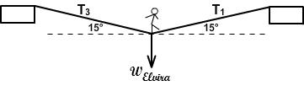

Figure 10: Elvira at the Center of the Slackwire

Without changing the masses used in part II, adjust both angles to 15°.

- What does the symmetry of the figure suggest about how the tensions T1, and T3 should compare?

T3 will still tend to have more tension since the masses were not changed

- Similarly what can you say about comparative values of the x-components T1x and T3x? (Ex. Maybe T1x = 2× T3x?)

The x-components T1x and T3x value will not change.

- What can you say about comparative values of the y-components T1y and T3y?

The y-components T1y and T3y will be equal since the tensional values T1, and T3 do not change.

- Knowing that the weight being supported is 450 N, what can you say about actual values of the y-components T1y and T3y?

T1y = 225N
T3y = 225N
The values of T1y and T3y are equal.

5. T1y = T3y = 225 N

You can now easily calculate T1 and hence T3.

VPL Lab - Force Table 6 Rev 12/19/18

6. T1 = T3 = 869.33N at 15°

Show the calculation of T1 below.
Fy = Fsin(θ)
F= Fy/Sin(θ)
F = 225/sin(15) = 869.33N

- Change each T to as close as you can get to this amount. Does this produce equilibrium?

Yes it will produce an equilibrium since it will bring the y-components T1y and T3y to equal values.

- With your apparatus, create the two vector arrows to match this amount - one for T1 and one for T3. Add T1 + T3 + W graphically. Draw or paste a copy of this graphical addition below.

9. Create the two vector arrows to

match this amount - one for T1
and one for T3. Add T1 + T3 +
W graphically. Draw or paste a
copy of this graphical addition
in Figure 11.
10. Take a Screenshot, save it
locally as “FTable_11.png”,
print it out, and paste it in the
space provided.

Figure 11: Graphical Addition – Symmetrical

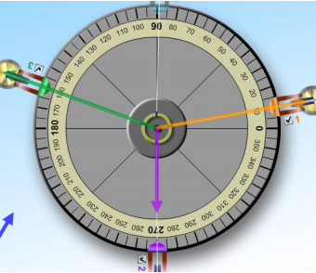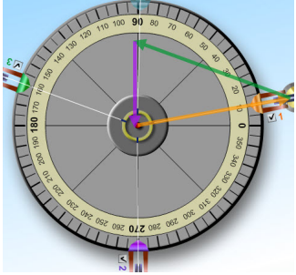

VPL Lab - Force Table 7 Rev 12/19/18

You’ll notice that this figure doesn’t differ much from the previous one. The graphical tool we’re using is not very precise. The same goes for “the real world.” Measuring the tension in a heavy electrical cable or bridge support cable is very difficult. One good method involves whacking it with a hammer and listening for the note it play!

